Job no:02

Job name :link, Marquee tag , Anchor tag

Input:

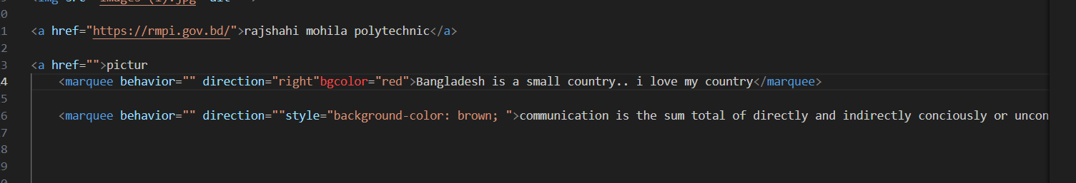

Output:

## 